The Texas Migrant Education Program provides a variety of educational services to families who work, in agriculture, regardless of their nationality or legal status. This program is free of charge to all eligible families and may include:

- early childhood programs (ages 3-5)
- free lunch eligibility
- drop-out prevention
- medical service information
- free tutoring program referrals
- parent engagement activities
- other services as needed

A program employee may contact you for further information if needed.

Child’s Name: __________________________________________________________________________

Birthdate: ________________ Grade: ______ School: __________________________________
________________________________________________________________________________________
- Has anyone in your household had a job working on a farm, in a field, in a greenhouse, in a nursery or in a packing house? (not including your own property) Please circle all that apply.
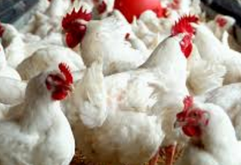
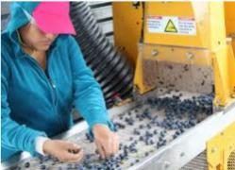
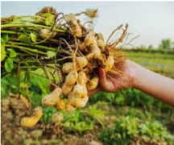
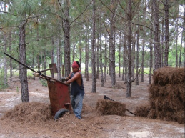
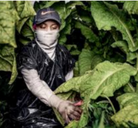

Eggs
Fruits
Vegetables
Tobacco
Pine Straw
Chickens
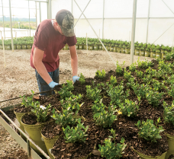
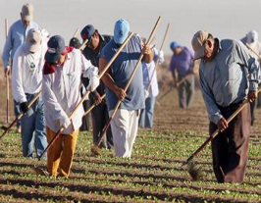
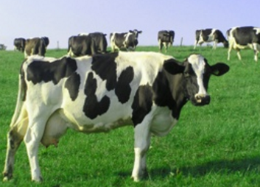
Soil Preparation (planting, weeding, etc.)
Nursery, Sod, Greenhouse
Flowers
Livestock (cattle,
pigs, sheep, dairy, etc.).
Other agriculture work:
_______________

Processing (meat,
fruit, vegetables, trees. etc.)

If you circle one of more, continue to #2. None of these ____ (stop here)

- In the past 3 years, have you or another member of your household traveled to another county or another state to do this work? (including during the summer, winter or spring break)

Yes __________ No __________

For more information, please contact the Migrant Education Program:
Please send completed forms to your schools.

